* **[How to create a subtask](https://sharepoint.rackspace.com/learning/articles/Pages/SharePoint-2013--how-to-create-a-subtask.aspx)**

1. From the home page of your SharePoint site open any task list you would like, in this example I will open my “**Team Tasks**” task list. 

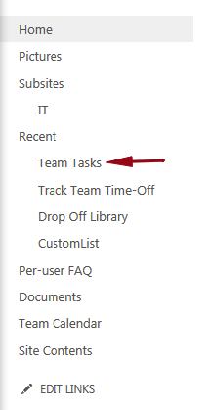

2. Click the ellipsis **…** next to the item you want to add the sub-task.  
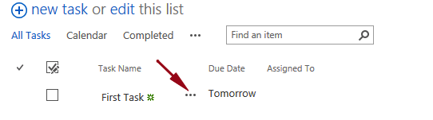

3. From the pop-up click **CREATE SUBTASK**.  
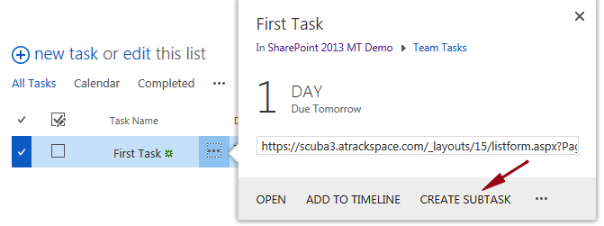

4. Enter a Task Name, I will call mine “**Subtask**”.  
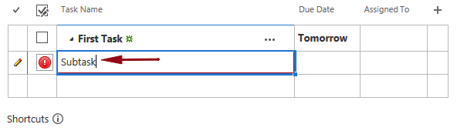

5. Hit **Enter**.  
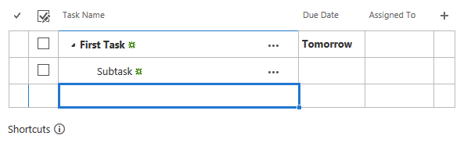

6. Click **Stop** editing this list.  


7. You will now see your new subtask below “First Task”.  Also, notice Subtask is indented.

